Question 1- https://www.hackerrank.com/challenges/functions-in-c/problem
Solution
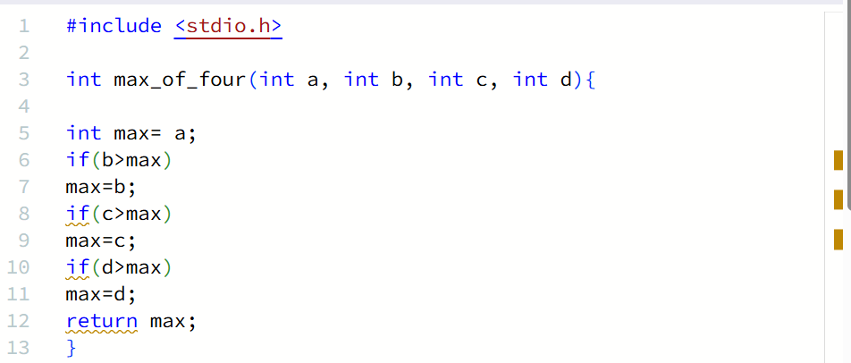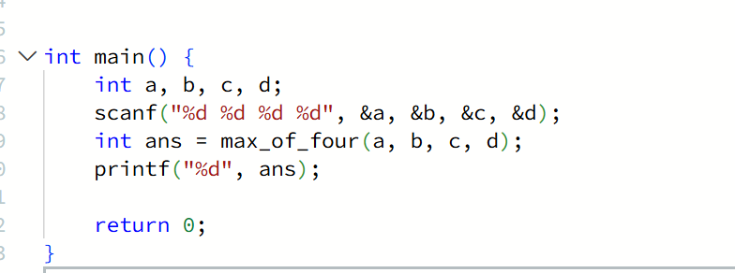

Question 2 https://leetcode.com/problems/move-zeroes/submissions/2190553349/
Solution
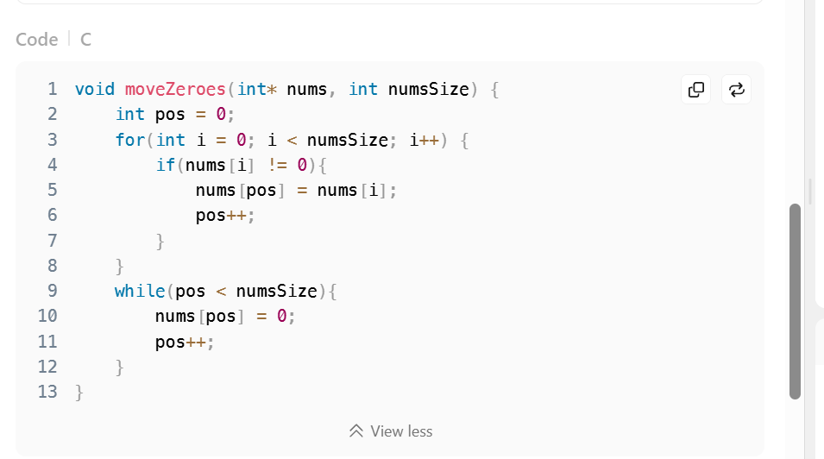
Question 3 https://www.hackerearth.com/practice/basic-programming/input-output/basics-of-input-output/practice-problems/algorithm/io-exercise/?update=google&purpose=login&source=login
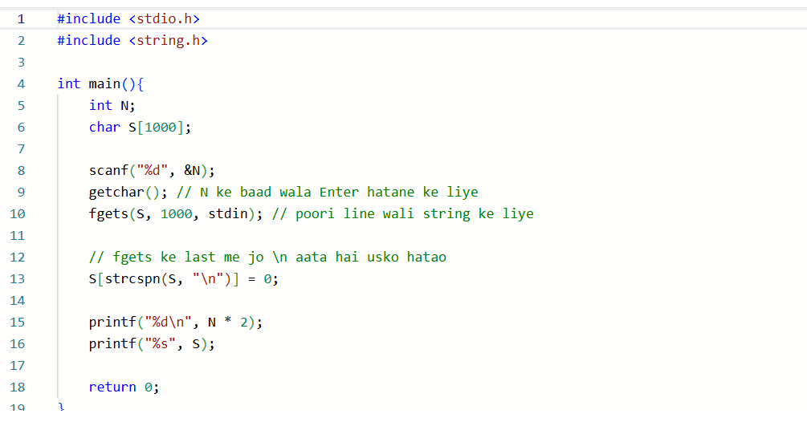
Question 4 https://www.hackerrank.com/challenges/solve-me-first/problem
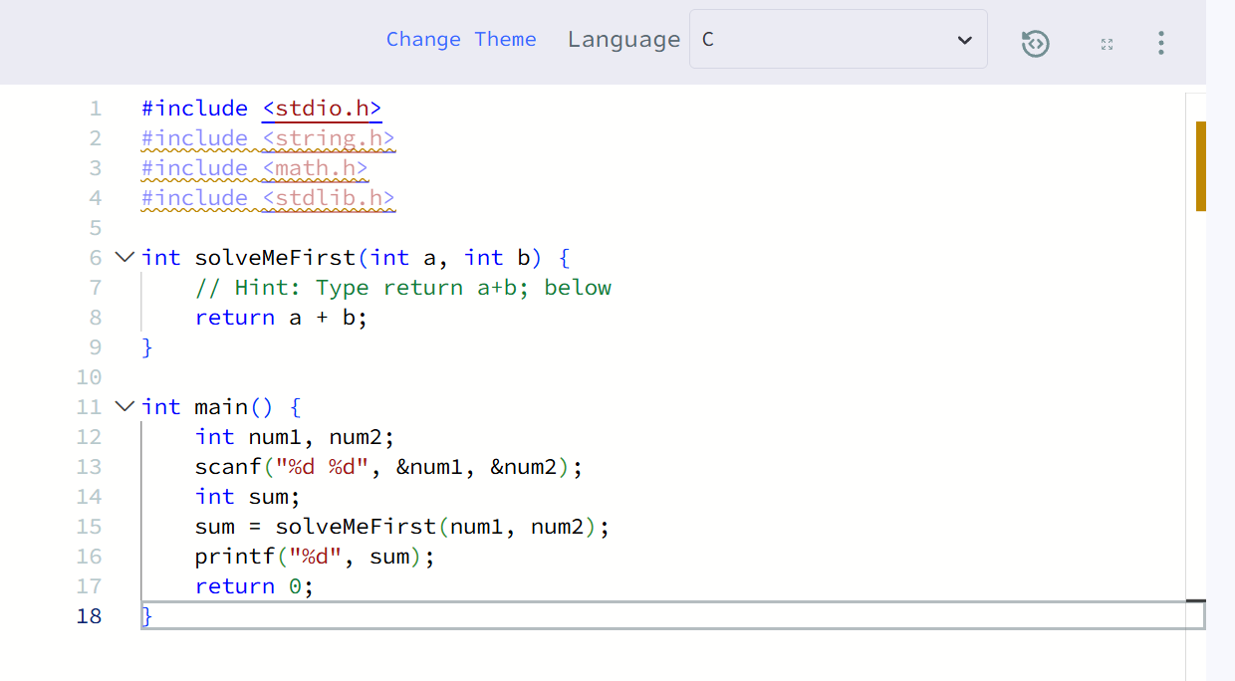
Question 5 https://www.hackerearth.com/practice/basic-programming/input-output/basics-of-input-output/practice-problems/algorithm/roy-and-profile-picture/
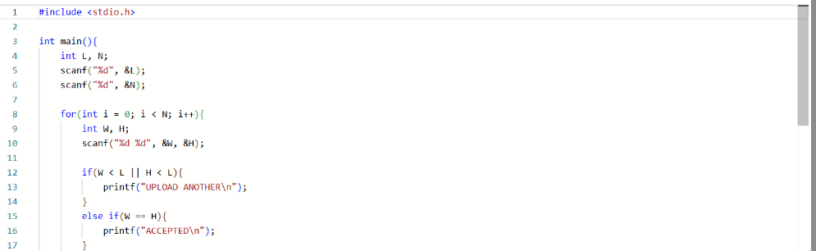

Question 6 https://www.hackerrank.com/challenges/fizzbuzz/problem
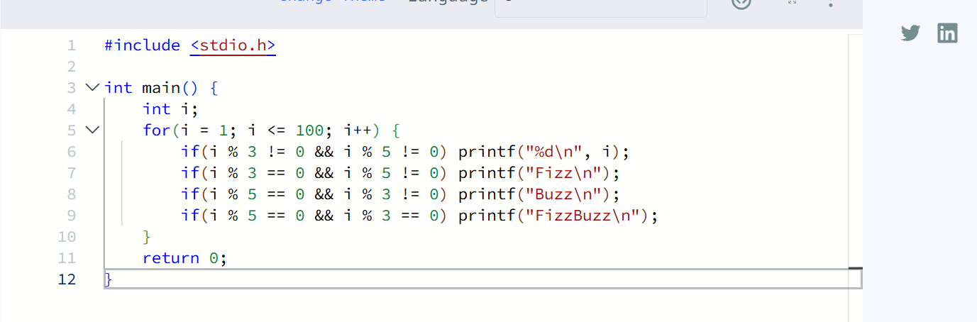

Question 7 https://www.hackerearth.com/problem/algorithm/digit-sum-4/


